Essential Cell Biology, Fourth Edition
Chapter 1: Cells: The Fundamental Units of Life
© 2014 Garland Science Publishing

Unity and Diversity of Cells

1-1 Living systems are incredibly diverse in size, shape, environment, and behavior. It is estimated that there are between 10 million and 100 million different species. Despite this wide variety of organisms, it remains difficult to define what it means to say something is alive. Which of the following can be described as the smallest living unit?
(a) DNA
(b) cell
(c) organelle
(d) protein

1-2 Indicate whether the following statements are true or false. If the statement is false, explain why it is false.
A. The Paramecium is a multicellular microorganism covered with hairlike cilia.
B. Cells of different types can have different chemical requirements.
C. The branchlike extensions that sprout from a single nerve cell in a mammalian brain can extend over several hundred micrometers.

1-3 For each of the following sentences, fill in the blanks with the best word or phrase selected from the list below. Not all words or phrases will be used; each word or phrase should be used only once.

Cells can be very diverse: superficially, they come in various sizes, ranging from bacterial cells such as Lactobacillus, which is a few __________________ in length, to larger cells such as a frog’s egg, which has a diameter of about one __________________. Despite the diversity, cells resemble each other to an astonishing degree in their chemistry. For example, the same 20 __________________ are used to make proteins. Similarly, the genetic information of all cells is stored in their __________________. Although __________________ contain the same types of molecules as cells, their inability to reproduce themselves by their own efforts means that they are not considered living matter.

amino acids micrometer(s) viruses
DNA millimeter(s) yeast
fatty acids plants
meter plasma membranes

1-4 How does cellular specialization serve multicellular organisms and how might a high degree of specialization be detrimental?

1-5 The flow of genetic information is controlled by a series of biochemical reactions that result in the production of proteins, each with its own specific order of amino acids. Choose the correct series of biochemical reactions from the options presented here.
(a) replication, transcription, translation
(b) replication, translation, transcription
(c) translation, transcription, replication
(d) translation, replication, transcription

1-6 Proteins are important architectural and catalytic components within the cell, helping to determine its chemistry, its shape, and its ability to respond to changes in the environment. Remarkably, all of the different proteins in a cell are made from the same 20 __________. By linking them in different sequences, the cell can make protein molecules with different conformations and surface chemistries, and therefore different functions.
(a) nucleotides.
(b) sugars.
(c) amino acids.
(d) fatty acids.

1-7 Which statement is NOT true about mutations?
(a) A mutation is a change in the DNA that can generate offspring less fit for survival than their parents.
(b) A mutation can be a result of imperfect DNA duplication.
(c) A mutation is a result of sexual reproduction.
(d) A mutation is a change in the DNA that can generate offspring that are as fit for survival as their parents are.

1-8 Changes in DNA sequence from one generation to the next may result in offspring that are altered in fitness compared with their parents. The process of change and selection over the course of many generations is the basis of __________.
(a) mutation.
(b) evolution.
(c) heredity.
(d) reproduction.

1-9 Select the option that best finishes the following statement: “Evolution is a process __________.”
(a) that can be understood based on the principles of mutation and selection.
(b) that results from repeated cycles of adaptation over billions of years.
(c) by which all present-day cells arose from 4–5 different ancestral cells.
(d) that requires hundreds of thousands of years.

1-10 Select the option that correctly finishes the following statement: “A cell’s genome _________________.”
(a) is defined as all the genes being used to make protein.
(b) contains all of a cell’s DNA.
(c) constantly changes, depending upon the cell’s environment.
(d) is altered during embryonic development.

Cells Under the Microscope

1-11 Which statement is NOT true about the events/conclusions from studies during the mid-1800s surrounding the discovery of cells?
(a) Cells came to be known as the smallest universal building block of living organisms.
(b) Scientists came to the conclusion that new cells can form spontaneously from the remnants of ruptured cells.
(c) Light microscopy was essential in demonstrating the commonalities between plant and animal tissues.
(d) New cells arise from the growth and division of previously existing cells.

1-12 What unit of length would you generally use to measure a typical plant or animal cell?
(a) centimeters
(b) nanometers
(c) millimeters
(d) micrometers

1-13 Match the type of microscopy on the left with the corresponding description provided below. There is one best match for each.
A. confocal
B. transmission electron
C. fluorescence
D. phase-contrast
E. scanning electron
F. bright-field

____ uses a light microscope with an optical component to take advantage of the different refractive indices of light passing through different regions of the cell.
____ employs a light microscope and requires that samples be fixed and stained in order to reveal cellular details.
____ requires the use of two sets of filters. The first filter narrows the wavelength range that reaches the specimen and the second blocks out all wavelengths that pass back up to the eyepiece except for those emitted by the dye in the sample.
____ scans the specimen with a focused laser beam to obtain a series of two-dimensional optical sections, which can be used to reconstruct an image of the specimen in three dimensions. The laser excites a fluorescent dye molecule, and the emitted light from each illuminated point is captured through a pinhole and recorded by a detector.
____ has the ability to resolve cellular components as small as 2 nm.
____ requires coating the sample with a thin layer of a heavy metal to produce three-dimensional images of the surface of a sample.

1-14 Indicate whether the following statements are true or false. If the statement is false, explain why it is false.
A. The nucleus of an animal cell is round, small, and difficult to distinguish using light microscopy.
B. The presence of the plasma membrane can be inferred by the well-defined boundary of the cell.
C. The cytosol is fairly empty, containing a limited number of organelles, which allows room for rapid movement via diffusion.

1-15 Cell biologists employ targeted fluorescent dyes or modified fluorescent proteins in both standard fluorescence microscopy and confocal microscopy to observe specific details in the cell. Even though fluorescence permits better visualization, the resolving power is essentially the same as that of a standard light microscope because the resolving power of a microscope is limited by the __________ of light.
(a) absorption
(b) intensity
(c) filtering
(d) wavelength

1-16 What is the smallest distance two points can be separated and still resolved using light microscopy?
(a) 20 nm
(b) 0.2 μm
(c) 2 μm
(d) 200 μm

The Prokaryotic Cell

1-17 By definition, prokaryotic cells do not possess __________.
(a) a nucleus.
(b) replication machinery.
(c) ribosomes.
(d) membrane bilayers.

1-18 Although there are many distinct prokaryotic species, most have a small range of shapes, sizes, and growth rates. Which of the following characteristics are not observed in prokaryotes?
(a) a highly structured cytoplasm
(b) endoplasmic reticulum
(c) the ability to divide rapidly
(d) a cell wall

1-19 Indicate whether the following statements are true or false. If the statement is false, explain why it is false.
A. The terms “prokaryote” and “bacterium” are synonyms.
B. Prokaryotes can adopt several different basic shapes, including spherical, rod-shaped, and spiral.
C. Some prokaryotes have cell walls surrounding the plasma membrane.

1-20 Prokaryotic cells are able to evolve very fast, which helps them to rapidly adapt to new food sources and develop resistance to antibiotics. Which of the options below lists the three main characteristics that support the rapid evolution of prokaryotic populations?
(a) microscopic, motile, anaerobic
(b) aerobic, motile, rapid growth
(c) no organelles, cell wall, can exchange DNA
(d) large population, rapid growth, can exchange DNA

1-21 Indicate whether the following statements are true or false. If the statement is false, explain why it is false.
A. Oxygen is toxic to certain prokaryotic organisms.
B. Mitochondria are thought to have evolved from anaerobic bacteria.
C. Photosynthetic bacteria contain chloroplasts.

1-22 Some prokaryotes can live by utilizing entirely inorganic materials. Which of the following inorganic molecules would you predict to be the predominant building block for fats, sugars, and proteins?
(a) O₂
(b) N₂
(c) CO₂
(d) H₂

The Eukaryotic Cell

1-23 Use the list of structures below to label the schematic drawing of an animal cell in Figure Q1-23.
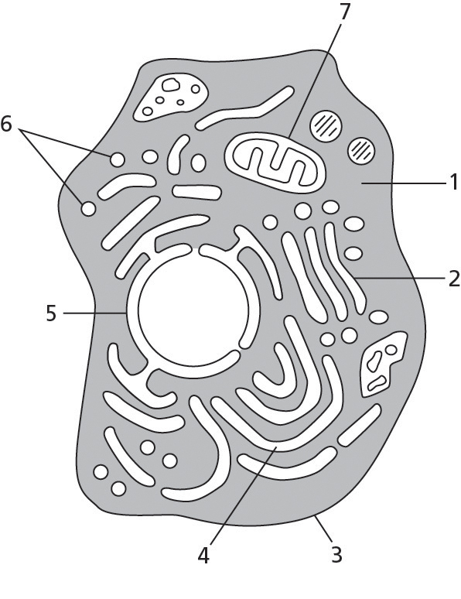
Figure Q1-23

A. plasma membrane
B. nuclear envelope
C. cytosol
D. Golgi apparatus
E. endoplasmic reticulum
F. mitochondrion
G. transport vesicles

1-24 For each of the following sentences, fill in the blanks with the best word or phrase selected from the list below. Not all words or phrases will be used; each word or phrase should be used only once.

Eukaryotic cells are bigger and more elaborate than prokaryotic cells. By definition, all eukaryotic cells have a __________________, usually the most prominent organelle. Another organelle found in essentially all eukaryotic cells is the __________________, which generates the chemical energy for the cell. In contrast, the __________________ is a type of organelle found only in the cells of plants and algae, and performs photosynthesis. If we were to strip away the plasma membrane from a eukaryotic cell and remove all of its membrane-enclosed organelles, we would be left with the __________________, which contains many long, fine filaments of protein that are responsible for cell shape and structure and thereby form the cell’s __________________.

chloroplast cytosol nucleus
chromosome endoplasmic reticulum ribosomes
cytoskeleton mitochondrion

1-25 The __________ __________ is made up of two concentric membranes and is continuous with the membrane of the endoplasmic reticulum.
(a) plasma membrane
(b) Golgi network
(c) mitochondrial membrane
(d) nuclear envelope

1-26 The nucleus, an organelle found in eukaryotic cells, confines the __________, keeping them separated from other components of the cell.
(a) lysosomes
(b) chromosomes
(c) peroxisomes
(d) ribosomes

1-27 Which of the following organelles has both an outer and an inner membrane?
(a) endoplasmic reticulum
(b) mitochondrion
(c) lysosome
(d) peroxisome

1-28 Mitochondria perform cellular respiration, a process that uses oxygen, generates carbon dioxide, and produces chemical energy for the cell. Which answer below indicates a correct pairing of material “burned” and the form of energy produced during cellular respiration?
(a) fat, ADP
(b) sugar, fat
(c) sugar, ATP
(d) fat, protein

1-29 You fertilize egg cells from a healthy plant with pollen (which contains the male germ cells) that has been treated with DNA-damaging agents. You find that some of the offspring have defective chloroplasts, and that this characteristic can be passed on to future generations. This surprises you at first because you happen to know that the male germ cell in the pollen grain contributes no chloroplasts to the fertilized egg cell and thus to the offspring. What can you deduce from these results?

1-30 Mitochondria contain their own genome, are able to duplicate, and actually divide on a different time line from the rest of the cell. Nevertheless, mitochondria cannot function for long when isolated from the cell because they are __________________.
(a) viruses.
(b) parasites.
(c) endosymbionts.
(d) anaerobes.

1-31 The mitochondrial proteins found in the inner membrane are involved in the conversion of ADP to ATP, a source of energy for the cell. This process consumes which of the following substances?
(a) oxygen
(b) nitrogen
(c) sulfur
(d) carbon dioxide

1-32 Indicate whether the following statements are true or false. If the statement is false, explain why it is false.
A. With respect to cellular respiration, the only organelles used by animal cells are mitochondria, while plant cells use both mitochondria and chloroplasts.
B. The number of mitochondria inside a cell remains constant over the life of the cell.

1-33 Chloroplasts are found only in eukaryotic cells that carry out photosynthesis: plants and algae. Plants and algae appear green as a result of the presence of chlorophyll. Where is chlorophyll located in the chloroplast?
(a) in the first, outer membrane
(b) in the space between the first and second membranes
(c) in the second, inner membrane
(d) in the third, innermost membrane

1-34 Photosynthesis enables plants to capture the energy from sunlight. In this essential process, plants incorporate the carbon from CO₂ into high-energy __________ molecules, which the plant cell mitochondria use to produce ATP.
(a) fat
(b) sugar
(c) protein
(d) fiber

1-35 Indicate whether the following statements are true or false. If the statement is false, explain why it is false.
A. Membrane components in the cell are made in the endoplasmic reticulum.
B. The Golgi apparatus is made up of a series of membrane-enclosed compartments through which materials destined for secretion must pass.
C. Lysosomes are small organelles where fatty acid synthesis occurs.

1-36 Circle the appropriate cell type in which the listed structure or molecule can be found. Note that the structure or molecule can be found in more than one type of cell.

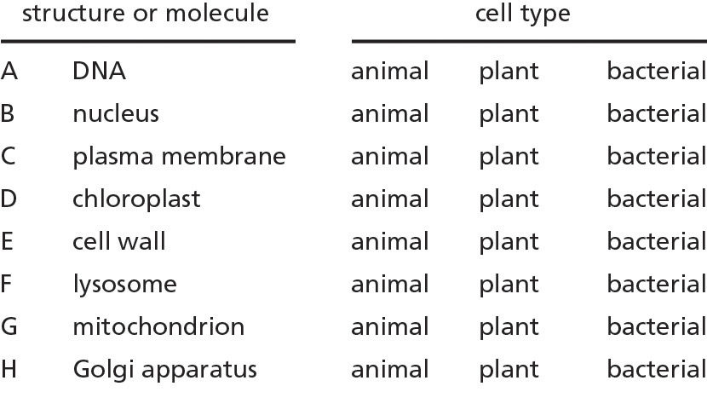

1-37 Which of the following choices best describes the role of the lysosome?
(a) transport of material to the Golgi
(b) clean-up, recycling, and disposal of macromolecules
(c) sorting of transport vesicles
(d) the storage of excess macromolecules

1-38 The protozoan Didinium feeds on other organisms by engulfing them. Why are bacteria, in general, unable to feed on other cells in this way?

1-39 The cell constantly exchanges materials by bringing nutrients in from the external environment and shuttling unwanted by-products back out. Which term describes the process by which external materials are captured inside vesicles and brought into the cell?
(a) degradation
(b) exocytosis
(c) phagocytosis
(d) endocytosis

1-40 Eukaryotic cells are able to trigger the release of material from secretory vesicles to the extracellular space using a process called exocytosis. An example of materials commonly released this way is _____________.
(a) hormones.
(b) nucleic acids.
(c) sugars.
(d) cytosolic proteins.

1-41 __________ are fairly small organelles that provide a safe place within the cell to carry out certain biochemical reactions that generate harmful, highly reactive oxygen species. These chemicals are both generated and broken down in the same location.
(a) Nucleosomes
(b) Lysosomes
(c) Peroxisomes
(d) Endosomes

1-42 The cytoskeleton provides support, structure, motility, and organization, and it forms tracks to direct organelle and vesicle transport. Which of the cytoskeletal elements listed below is the thickest?
(a) actin filaments
(b) microtubules
(c) intermediate filaments
(d) none of the above (all the same thickness)

1-43 Despite the differences between eukaryotic and prokaryotic cells, prokaryotes have proteins that are distantly related to eukaryotic actin filaments and microtubules. What is likely to be the most ancient function of the cytoskeleton?
(a) cell motility
(b) vesicle transport
(c) membrane support
(d) cell division

1-44 Which of the following characteristics would not support the idea that the ancestral eukaryote was a predator cell that captured and consumed other cells?
(a) dynamic cytoskeleton
(b) large cell size
(c) ability to move
(d) rigid membrane

1-45 Choose the phrase that best completes this sentence: Microtubules ____________ and are required to pull duplicated chromosomes to opposite poles of dividing cells.
(a) generate contractile forces
(b) are intermediate in thickness
(c) can rapidly reorganize
(d) are found in especially large numbers in muscle cells

1-46 Indicate whether the following statements are true or false. If the statement is false, explain why it is false.
A. Plants do not require a cytoskeleton because they have a cell wall that lends structure and support to the cell.
B. The cytoskeleton is used as a transportation grid for the efficient, directional movement of cytosolic components.
C. Thermal energy promotes random movement of proteins, vesicles, and small molecules in the cytosol.

1-47 Which pair of values best fills in the blanks in this statement: On average, eukaryotic cells are __________ times longer and have _________ times more volume than prokaryotic cells.
(a) 5, 100
(b) 10, 200
(c) 10, 100
(d) 10, 1000

1-48 Indicate whether the following statements are true or false. If the statement is false, explain why it is false.
A. Primitive plant, animal, and fungal cells probably acquired mitochondria after they diverged from a common ancestor.
B. Protozoans are single-celled eukaryotes with cell morphologies and behaviors that can be as complex as those of some multicellular organisms.
C. The first eukaryotic cells on Earth must have been aerobic; otherwise, they would not have been able to survive when the planet’s atmosphere became oxygen-rich.

Model Organisms

1-49 Given what you know about the differences between prokaryotic cells and eukaryotic cells, rate the following things as “good” or “bad” processes to study in the model organism E. coli.
A. formation of the endoplasmic reticulum
B. DNA replication
C. how the actin cytoskeleton contributes to cell shape
D. how cells decode their genetic instructions to make proteins
E. how mitochondria get distributed to cells during cell division

1-50 Scientists learned that cell death is a normal and even important part of life by studying the development of the nematode worm C. elegans. What was the most important feature of C. elegans for the study of programmed cell death?
(a) The nematode is smaller and simpler than the fruit fly.
(b) 70% of C. elegans genes have homologs in humans.
(c) The developmental pathway of each cell in the adult worm was known.
(d) Its genome was partially sequenced.

1-51 Biologists cannot possibly study all living species. Instead, they try to understand cell behavior by studying a select subset of them. Which of the following characteristics are useful in an organism chosen for use as a model in laboratory studies?
(a) amenability to genetic manipulation
(b) ability to grow under controlled conditions
(c) rapid rate of reproduction
(d) all of the above

1-52 Many of the mechanisms that cells use for maintenance and reproduction were first studied at the molecular level in bacteria. Which bacterial species had a central role in advancing the field of molecular biology?
(a) E. coli
(b) D. melanogaster
(c) S. pombe
(d) C. elegans

1-53 Brewer’s yeast, apart from being an irreplaceable asset in the brewery and in the bakery, is an experimental organism used to study eukaryotic cells. However, it does have some limitations. Which of the processes below cannot be studied in yeast?
(a) DNA replication
(b) cell motility
(c) exocytosis
(d) cell division

1-54 For each process (A–D), circle the simplest model organism from the list of three that would be best used for investigation:

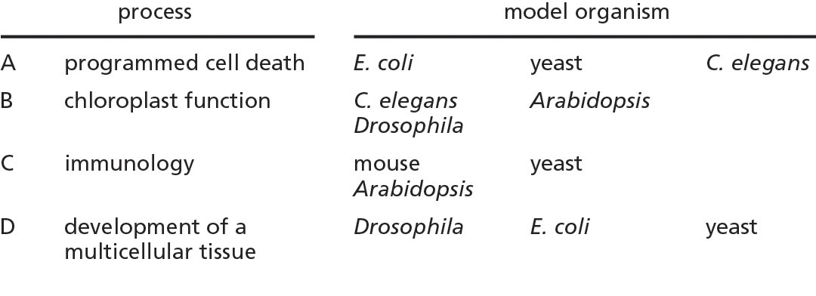

1-55 A. thaliana, or Arabidopsis, is a common weed. Biologists have selected it over hundreds of thousands of other flowering plant species to serve as an experimental model organism because __________________.
(a) it can withstand extremely cold climates.
(b) it can reproduce in 8–10 weeks.
(c) it produces thousands of offspring per plant.
(d) Both (b) and (c) are true.

1-56 Drosophila melanogaster is a/an __________. This type of animal is the most abundant of all animal species, making it an appropriate choice as an experimental model.
(a) insect
(b) bird
(c) amphibian
(d) mammal

1-57 Caenorhabditis elegans is a nematode. During its development, it produces more than 1000 cells. However, the adult worm has only 959 somatic cells. The process by which 131 cells are specifically targeted for destruction is called ______________.
(a) directed cell pruning.
(b) programmed cell death.
(c) autophagy.
(d) necrosis.

1-58 Zebrafish (Danio rerio) are especially useful in the study of early development because their embryos ______________.
(a) are exceptionally large.
(b) develop slowly.
(c) are transparent.
(d) are pigmented.

1-59 You wish to explore how mutations in specific genes affecting sugar metabolism might alter tooth development. Which organism is likely to provide the best model system for your studies, and why?
(a) horses
(b) mice
(c) E. coli
(d) Arabidopsis

1-60 Indicate whether the following statements are true or false. If the statement is false, explain why it is false.
A. The human genome is roughly 30 times larger than the Arabidopsis genome, but contains approximately the same number of protein-coding genes.
B. The variation in genome size among protozoans is larger than that observed across all species of mammals, birds, and reptiles.
C. The vast majority of our genome encodes functional RNA molecules or proteins and most of the intervening DNA is nonfunctional.

1-61 Genes that have homologs in a variety of species have been discovered through the analysis of genome sequences. In fact, it is not uncommon to find a family of homologous genes encoding proteins that are unmistakably similar in amino acid sequence in organisms as diverse as budding yeast, archaea, plants, and humans. Even more remarkably, many of these proteins can substitute functionally for their homologs in other organisms. Explain what it is about the origins of cells that makes it possible for proteins expressed by homologous genes to be functionally interchangeable in different organisms.

1-62 Match each biological process with the model organism that is best suited or most specifically useful for its study, based on information provided in your textbook. You may list individual processes more than once.
A. cell division
B. development (multicellular)
C. programmed cell death
D. photosynthesis
E. immunology

_____ A. thaliana (Arabidopsis)
_____ M. musculus (mouse)
_____ S. pombe
_____ C. elegans
_____ S. cerevisiae
_____ D. rerio (zebrafish)
_____ D. melanogaster

Testing the Concepts

1-63 Employ the principles of evolution discussed in this chapter to explain how the specific features and predatory behaviors of some primitive eukaryotes may have given them a selective advantage over others 1.5 billion years ago.

1-64 Evolutionary biologists have always used a broad range of modern organisms to infer the characteristics that ancestral organisms may have possessed. Genomic sequences are now available for an increasing number of species, and scientists studying evolutionary processes can take advantage of this enormous amount of data to bring evolution into the arena of molecular studies. By aligning the sequences of homologous genes and looking for regions of similarity and where changes have occurred, it is possible to infer the sequence of the ancestral gene.
A. What term is used to describe the changes in gene sequences that have occurred? How can we use what we know about this process to construct a time line showing when various sequence changes occurred and when they led to the modern sequences that we know today?
B. It is possible to express an ancestral gene sequence in modern organisms and subsequently compare the function of its product with that of the modern protein. Why might this approach give misleading conclusions?

1-65 The antibiotic streptomycin inhibits protein synthesis in bacteria. If this antibiotic is added to a culture of animal cells, protein synthesis in the cytosol continues normally. However, over time, the population of mitochondria in the cell becomes depleted. Specifically, it is observed that the protein-synthesis machinery inside the mitochondria is inhibited.
A. Explain this observation based on what you know about the origins of the modern eukaryote.
B. What do you expect to observe if, in a new experiment, animal cells are treated with diphtheria toxin, a compound that is known to block cytosolic protein synthesis but does not have any impact on bacterial growth?

1-66 You have been following the recent presidential elections and have heard some candidates disparaging excessive and “unnecessary” federal government expenditures. One particular candidate asks: “Why are we spending millions of dollars studying fruit flies? How can that possibly help us find a cure for cancer?” Use your knowledge of model organisms to explain why studies in D. melanogaster (the fruit fly) are actually an excellent use of research funding.

1-67 Cellular processes are often regulated by unknown mechanisms. In many cases, biologists work backward in an attempt to understand a process in which they are interested. This was the case when Nurse and Hartwell were trying to understand how cell division is controlled in yeast. Describe the process by which they “broke” the system and then supplied the “missing parts” to get the cell cycle running again. What further evidence did they collect to show that human cells and yeast cells regulate the cell cycle using a similar mechanism?

1-68 Your friend has just returned from a deep-sea mission and claims to have found a new single-celled life-form. He believes this new life-form may not have descended from the common ancestor that all types of life on Earth share. You are convinced that he must be wrong, and you manage to extract DNA from the cells he has discovered. He says that the mere presence of DNA is not enough to prove the point: his cells might have adopted DNA as a useful molecule quite independently of all other known life-forms. What could you do to provide additional evidence to support your argument?

answers

1-1 (b)

1-2 A. False. The Paramecium is a single-celled organism.
B. True.
C. True.

1-3 Cells can be very diverse: superficially, they come in various sizes, ranging from bacterial cells such as Lactobacillus, which is a few micrometers in length, to larger cells such as a frog’s egg, which has a diameter of about one millimeter. Despite the diversity, cells resemble each other to an astonishing degree in their chemistry. For example, the same 20 amino acids are used to make proteins. Similarly, the genetic information of all cells is stored in their DNA. Although viruses contain the same types of molecules as cells, their inability to reproduce themselves by their own efforts means that they are not considered living matter.

1-4 In a multicellular organism, the specialization of cells creates a division of labor and each type of cell relies on the activities of other cell types for survival. This cooperation between specialized cells is essential for the organism as a whole. If one of these overly specialized cells were removed from the context of the organism, it would not have the capabilities needed to generate offspring and would probably not even live very long.

1-5 (a)

1-6 (c)

1-7 (c)

1-8 (b)

1-9 (a)

1-10 (b)

1-11 (b)

1-12 (d)

1-13 D
F
C
A
B
E

1-14 A. False. The nucleus is one of the largest organelles and is the easiest organelle to discern within a typical cell.
B. True.
C. False. The cytosol is actually brimming with individual proteins, protein fibers, extended membrane systems, transport vesicles, and small molecules. And although cellular components do move by diffusion, the rate of movement is limited by the space available and the size of the component in question.

1-15 (d)

1-16 (b)

1-17 (a)

1-18 (a), (b)

1-19 A. False. Archaea make up a class of prokaryotic organisms that are significantly different from bacteria.
B. True.
C. True.

1-20 (d)

1-21 (a) True.
(b) False. Mitochondria use oxygen to generate energy and are thought to have evolved from aerobic bacteria.
(c) False. Photosynthetic bacteria have enzyme systems similar to those found in chloroplasts, which allow them to harvest light energy to fix carbon dioxide.

1-22 (c)

1-23 A. Plasma membrane—3
B. Nuclear envelope—5
C. Cytosol—1
D. Golgi apparatus—2
E. Endoplasmic reticulum—4
F. Mitochondrion—7
G. Transport vesicles—6

1-24 Eukaryotic cells are bigger and more elaborate than prokaryotic cells. By definition, all eukaryotic cells have a nucleus, usually the most prominent organelle. Another organelle found in essentially all eukaryotic cells is the mitochondrion, which generates the chemical energy for the cell. In contrast, the chloroplast is a type of organelle found only in the cells of plants and algae, and performs photosynthesis. If we were to strip away the plasma membrane from a eukaryotic cell and remove all of its membrane-enclosed organelles, we would be left with the cytosol, which contains many long, fine filaments of protein that are responsible for cell shape and structure and thereby form the cell’s cytoskeleton.

1-25 (d)

1-26 (b)

1-27 (b)

1-28 (c)

1-29 Your results show that not all of the information required for making a chloroplast is encoded in the chloroplast’s own DNA; some, at least, must be encoded in the DNA carried in the nucleus. The reasoning is as follows. Genetic information is carried only in DNA, so the defect in the chloroplasts must be due to a mutation in DNA. But all of the chloroplasts in the offspring (and thus all of the chloroplast DNA) must derive from those in the female egg cell, since chloroplasts only arise from other chloroplasts. Hence, all of the chloroplasts contain undamaged DNA from the female parent’s chloroplasts. In all the cells of the offspring, however, half of the nuclear DNA will have come from the male germ-cell nucleus, which combined with the female egg nucleus at fertilization. Since this DNA has been treated with DNA-damaging agents, it must be the source of the heritable chloroplast defect. Thus, some of the information required for making a chloroplast is encoded by the nuclear DNA.

1-30 (c)

1-31 (a)

1-32 A. False. In plants, only mitochondria perform cellular respiration (using oxygen to break down organic molecules to produce carbon dioxide) just as in animal cells. Chloroplasts perform photosynthesis in which water molecules are split to generate oxygen and fix carbon dioxide molecules.
B. False. Mitochondria have their own division cycle and their numbers change based on the rate of division.

1-33 (d)

1-34 (b)

1-35 A. True.
B. True.
C. False. Lysosomes house enzymes that break down nutrients for use by the cell and help recycle materials that cannot be used, which will later be excreted from the cell.

1-36
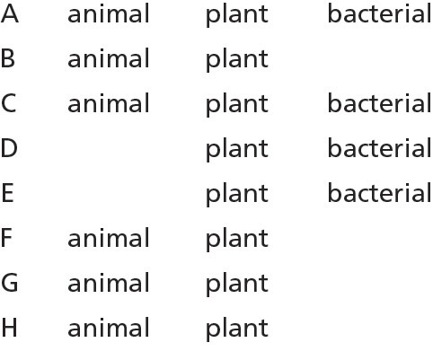

1-37 (b)

1-38 Didinium engulfs prey by changing its shape, and for this it uses its cytoskeleton. Bacteria have no cytoskeleton and cannot easily change their shape because they are generally surrounded by a tough cell wall.

1-39 (d)

1-40 (a)

1-41 (c)

1-42 (b)

1-43 (d)

1-44 (d)

1-45 (c)

1-46 A. False. Although plant cells do have a cell wall that lends structure and support, they still need a cytoskeleton, which also helps with connections between cells and the transport of vesicles inside the cell.
B. True.
C. True.

1-47 (d)

1-48 A. False. The mitochondria in modern plant, animal, and fungal cells are very similar, implying that these lines diverged after the mitochondrion was acquired by the ancestral eukaryote.
B. True.
C. False. The first eukaryotic cells likely contained a nucleus but no mitochondria. These ancestral eukaryotes subsequently adapted to survive in a world filled with oxygen by engulfing primitive aerobic prokaryotic cells.

1-49 A. bad
B. good
C. bad
D. good
E. bad

1-50 (c) This is the best answer because it was the prior developmental studies tracing cell lineages from the egg to the adult that allowed scientists to identify the precise time and location of cells that were being targeted for cell death. It was observed that this cell death was a normal and necessary part of the developmental pathway in the worm. Programmed cell death has since become known to be an important process in all multicellular eukaryotic organisms.

1-51 (d)

1-52 (a)

1-53 (b)
1-54

1-55 (b)

1-56 (a)

1-57 (b)

1-58 (c)

1-59 (b) Mice are likely to provide the best model system. Mice have teeth and have long been used as a model organism. Mice reproduce relatively rapidly and the extensive scientific community that works with mice has developed techniques to facilitate genetic manipulations. E. coli (a bacterium) and Arabidopsis (a plant) do not have teeth. Horses like sugar and have big teeth, but they would not be a good model organism. There is not an extensive scientific community working on the molecular and biochemical mechanisms of cell behaviors in horses; they are expensive and have a long reproduction time, which makes genetic studies costly and slow; and tools for genetic manipulation (other than traditional breeding) have not been developed.

1-60 A. True.
B. True.
C. False. It is a relatively small proportion of our DNA that encodes RNA and protein molecules. The majority of nonencoding sequences is probably involved in critical regulatory processes.

1-61 All living beings on Earth (and thus, all cells) are thought to be derived from a common ancestor. Solutions to many of the essential challenges that face a cell (such as the synthesis of proteins, lipids, and DNA) seem to have been achieved in this ancient common ancestor. The ancestral cell therefore possessed sets of proteins to carry out these essential functions. Many of the essential challenges facing modern-day cells are the same as those facing the ancestral cell, and the ancient solutions are often still effective. Thus, it is not uncommon for organisms to use proteins and biochemical pathways inherited from their ancestors. Although these proteins usually show some species-specific diversification, they still retain the basic biochemical characteristics of the ancestral protein. For example, homologous proteins often retain their ability to interact with a specific protein target, even in cells of diverse species. Because the basic biochemical characteristics are retained, homologous proteins are often capable of functionally substituting for one another.

1-62 B, D A. thaliana (Arabidopsis)
B, E M. musculus (mouse)
A S. pombe
C C. elegans
A S. cerevisiae
B D. rerio (zebrafish)
B D. melanogaster

1-63 The Earth’s atmosphere became oxygen-rich roughly 1.5 billion years ago. If some primitive predatory eukaryotic cells were similar to modern-day protozoans, they may have been mobile and able to engulf other cells. These characteristics would have been advantageous in the face of a changing atmosphere, and the establishment of a symbiotic relationship with an engulfed aerobe would have been selected for in the eukaryotic cell populations.

1-64 A. Changes in gene sequence occur through mutation. Mutations accumulate over time, occurring independently and at different sites in each gene lineage. Homologous genes that diverged recently will differ only slightly; genes that diverged long ago will differ more. Knowing the average mutation rate, you can estimate the time that has elapsed since the different versions of the gene diverged. By seeing how closely the various members of the family of homologous genes resemble one another, you can draw up a family tree, showing the sequence of lineage splits that lead from the ancestral gene to its many modern descendants. Suppose this family tree shows that family members A and B diverged from one another long ago, but that C diverged from B more recently; and suppose that at a certain site in the gene, A and B have the same sequence but C is different. Then, it is likely that the sequence of A and B is ancestral, while that of C reflects a recent mutation that has occurred in the lineage of C alone.
B. Although an inferred ancestral sequence can be reconstructed and the protein expressed, you would be placing an inferred, ancient protein in the context of a modern cell. If there are important interacting partners for the modern protein, there is a chance they may not recognize the ancestral protein, and therefore any information about its function may be inaccurate.

1-65 A. If the mitochondria originated from an ancient aerobic bacterium that was engulfed by an ancient eukaryote, as postulated, it is possible that an antibiotic that inhibits protein synthesis in bacteria could also block that process in mitochondria.
B. We would expect that although cytosolic protein synthesis would stop, mitochondrial protein synthesis should still occur normally (at least for a little while). This result would lend further support to the idea that mitochondria are derived from a noneukaryotic organism. If this were not the case, these compounds would be expected to affect protein synthesis at both locations.

1-66 Funding research on D. melanogaster is a worthwhile investment for several reasons: (1) working with insect animal models is relatively inexpensive; (2) fruit flies have historically proven useful in helping understand eukaryotic chromosome behavior; and (3) many of the genes in Drosophila are highly similar in sequence to the homologous human genes, and thus can be used to study human diseases.

1-67 Nurse and Hartwell first treated yeast cells with a chemical mutagen. The mutated population of cells was then grown and observed. Cells that demonstrated defects in cell-cycle regulation (characterized by cell-cycle arrest, larger-than-normal cells, and smaller-than-normal cells) were then isolated. The use of a library of plasmids that each express a normal gene from yeast cells allowed the scientists to identify exactly which gene could be used to “rescue” the mutant, because when the normal gene is expressed again, the cells return to a normal cell cycle. After this big result, the scientists went on to show that the homologous gene from other organisms could also rescue the mutant phenotype. The most exciting result was obtained with the human version of the cdc2 gene, which demonstrated that there are common principles underlying cell-cycle regulation across a large range of eukaryotic organisms.

1-68 You could use modern technology to discover the sequence of the DNA. If you are right, you would expect to find parts of this sequence that are unmistakably similar to corresponding sequences in other, familiar, living organisms; it would be highly improbable that such similar sequences would have evolved independently. You could, of course, also analyze other features of the chemistry of his cells; for example, do they contain proteins made of the same set of 20 amino acids? This could all be supporting evidence that this newly discovered species arose from the same common ancestral cells as all other life on Earth.

